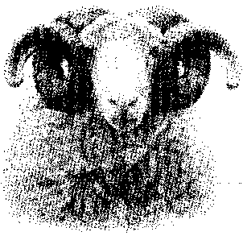

Whitefaced Woodland Sheep Society

Secretary: Rachel Godschalk
Plover Hall, Gilmonby, Barnard Castle DL12 9LU
mobile: 07962 152242
e-mail: rachel@cerdan.co.uk

MEMBERSHIP APPLICATION

Annual membership of the Whitefaced Woodland Sheep Society is £20 and runs from 1 September to 31 August. Please make cheques payable to ‘WWSS’ and send to me at the above address. If you are willing to receive communications and newsletters by e-mail, please let me have your e-mail address, as this gives quicker access and helps to keep our costs down. A form is also available for standing orders if required.

How we use your data

The WWSS holds basic contact details of members and enquirers and details of their sheep, together with publically available information from shows and sales. We hold no financial data, apart from current subscription status. This information is used to produce certificates and our annual register, and to send out our newsletters. It is occasionally circulated to members. It is never sold or made available to other bodies. You may ask to see the data we hold on you, or ask for it to be changed or removed.

Rachel Godschalk
(Secretary & Membership)

Surname

First name

Address

Postcode

Telephone number/ mobile

E-mail address

Flock name (if applicable)

Approx no. of breeding ewes

TELEPHONE (Mobile):

E-MAIL ADDRESS:

FLOCK NAME:

APPROX. NO. OF BREEDING EWES:

